Safe Disposal of Hazardous Waste

First: Hazardous Medical Waste:
Hazardous medical waste is disposed of through shredding and sterilization devices (medical waste shredders) at the Medical Waste Management Unit of Assiut University Hospitals. Necessary tests are conducted on the shredded waste to ensure it is free from microbes, in accordance with the decisions of the Ministry of Health (as per the decision of the Committee on Hazardous Materials and Waste.
Second: Hazardous Waste Under Condition
- Fluorescent bulbs are disposed of by sending them to the Nasiriyah Center for Hazardous Waste Management, where there is a system in place for their safe treatment and disposal.
- Expired Medications and Chemicals:
These are collected by the designated committees and then delivered to the Nasiriyah Center for Hazardous Waste Management, where a system is in place for their safe treatment and disposal.
- Used Oils:
Used oils from cars, diesel, and other sources are collected and gathered. They are then handed over to contracted companies that hold the necessary licenses and environmental approvals for recycling these oils.
Correspondence with the relevant authorities for the establishment of an incineration complex in the Western Desert Backdrop for Assiut University Hospitals, covering an area of 15,000 square meters, for the disposal of hazardous waste.
- Disposal of Organic Waste:
Regarding tree and food waste, disposal is handled by:
Collection by the university's landscaping teams, who manage disposal.
Removal by a contracted private company responsible for collecting, separating, and ensuring proper disposal.
Collection and disposal by contracted waste handlers under the supervision of the University’s Gardens and Environmental Projects Management.
South Egypt Cancer Institute
Hazardous Materials and Waste at the University Cancer Hospital and Methods of Disposal.

Project Documents for Assiut University Hospital:
Safe disposal of hazardous medical waste through shredding and sterilization devices.

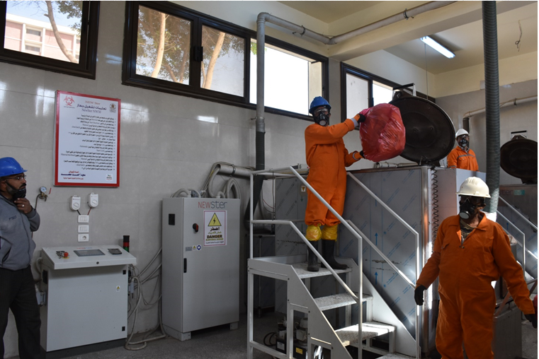
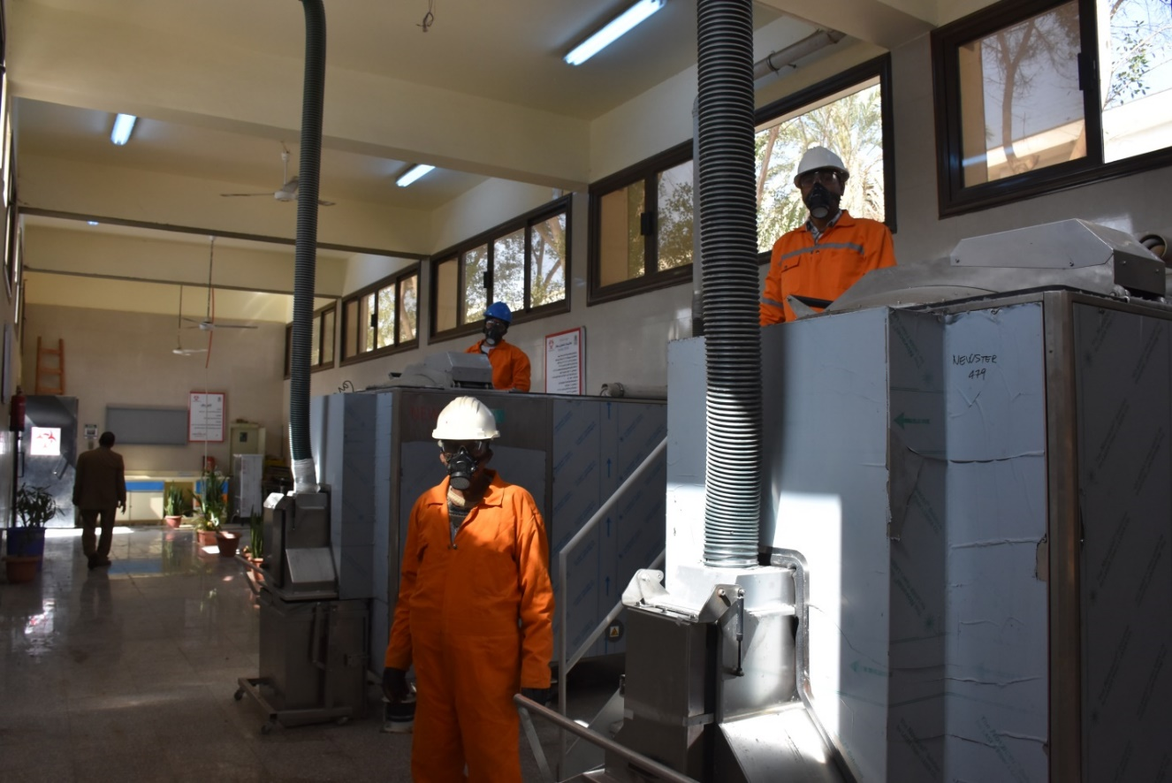
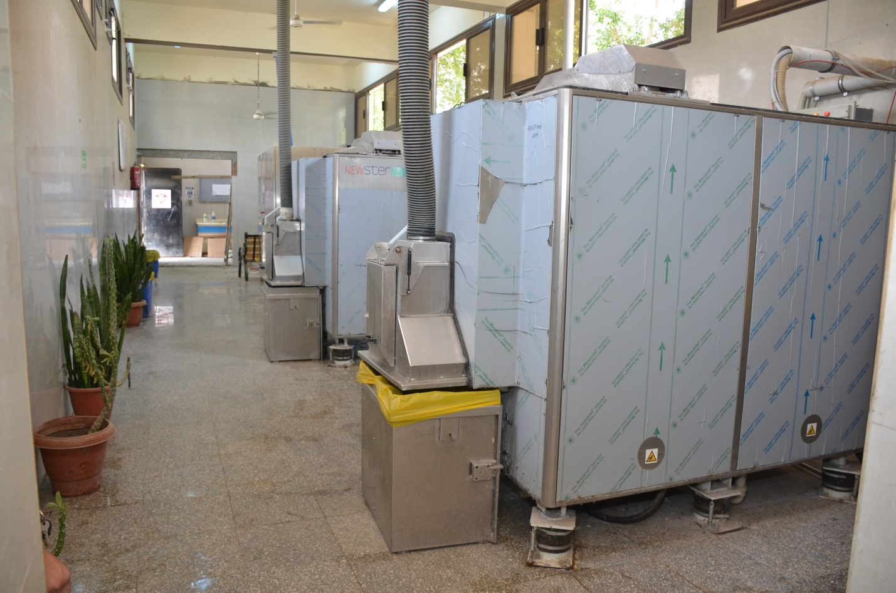

Project for the Establishment of a Central Medical Waste Treatment Plant at Assiut University Hospitals
Introduction
Project for the Establishment of a Central Medical Waste Treatment Plant at Assiut University Hospitals
Assiut University Hospitals is a prominent medical complex in Upper Egypt, comprising 11 university hospitals with a capacity of more than 4,000 beds, in addition to 3 other hospitals currently being prepared for construction. The complex also includes outpatient clinics, operating departments, laboratories, and radiology units.
These hospitals generate more than 5,000 kg of hazardous medical waste daily, which necessitates effective solutions for the safe disposal of this waste. Proper disposal is crucial to maintaining both internal and external environmental safety and preventing the spread of infections from this waste, which poses a significant threat if not handled correctly.
The successive administrations of Assiut University and its hospitals have addressed this issue with great importance. In 1988, a university hospital incinerator was established, followed by the creation of a unit equipped with medical waste shredding and sterilization devices. Additionally, a medical waste management unit was set up in 2017.
Given the increasing number of university hospitals and the continuous efforts across all hospitals to provide high-quality medical services and reduce waiting lists, a large amount of medical waste is generated. This volume exceeds the capacity of the existing waste disposal equipment, such as outdated incinerators and shredding/sterilization devices. Therefore, it became essential for the university administration and hospital management to come together and address this issue with a forward-looking vision, developing appropriate solutions.
The most suitable solution, in line with global standards for the safe disposal of medical waste, is the establishment of a central medical waste treatment plant (shredding and sterilization) to manage the waste generated by university hospitals.
Project Objective
Safe disposal of medical waste generated by Assiut University Hospitals.
Proposed Location
The current location of the university hospital incinerators, situated at the university farm, has been proposed. The incinerators will be relocated to a new site in the desert hinterland. The proposed location is already equipped with electricity, water, natural gas, administrative offices, storage areas, and restrooms.
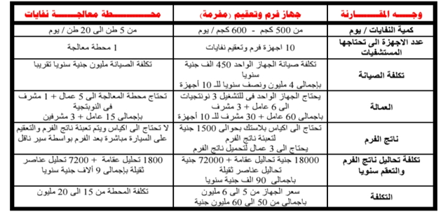

Disposal of Hazardous Waste of Faculty of science:
As the Faculty of Science is a practical faculty where numerous scientific research activities and student laboratory work are conducted, a significant amount of hazardous waste is generated, both chemical and biological. To ensure the safe disposal of such waste, a mechanism has been established. Hazardous waste in laboratories is separated and placed in special bags (red bags) and designated containers, after which it is disposed of by the Environmental Affairs Department.
For example, in the research laboratories of the Chemistry Department:
Some chemical substances are distilled and purified for reuse in washing equipment and for laboratory experiments.
Fractional distillation is used to separate certain organic solvents for reuse.
Chemical reaction by-products are treated with appropriate technology before disposal.
A clear mechanism is followed for the safe disposal of chemical waste, and a cooperation protocol is attached for hazardous waste disposal between the Competency Testing Center and the Environmental Affairs Department.
Disposal of Organic Waste:
- For tree and food waste, it is disposed of through the following methods:
- Collected by the university's landscaping teams and disposed of by them.
- Removed by a contracted private company responsible for collecting, sorting, and properly disposing of the waste.
- Collected and disposed of by waste contractors under the supervision of the university's Gardens and Environmental Projects Management.

